HISTORY
DOCUMENT OWNER | DOC REV# | DESCRIPTION OF CHANGE | DATE
Fuller, Ethan | 002 | Loctite 403 in Equipment and glue procedure 6.13 | 1/23/2023
Fuller, Ethan | 001 | Updated Logo & Reference Documents. Removed Sections 8 & 9. Included programmers in equipment. | 2/10/2022
Brunson, Travis | 000 | Initial Release | 10/3/2016

PURPOSE:
The purpose of this procedure is to define responsibility, authority and steps for testing Quantronix / Cubiscan 12841 Receiver PCA’s per customer specifications.
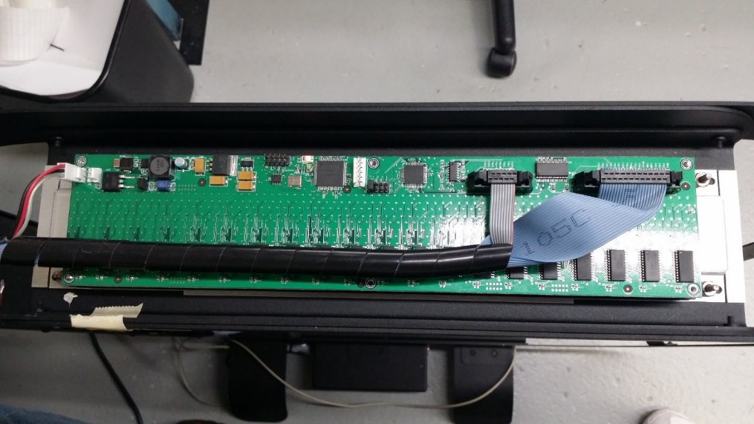

SCOPE:
This procedure applies to all personnel performing testing.

REFERENCE DOCUMENTS:

ISO 9001 / AS9100 / ISO 13485 Standards: Current Revisions

Quality Manual #422

Document and Data Control Procedure #423

Control of Records Procedure #424

PCA Test Procedure P0164

RESPONSIBILITIES:

The technician is responsible for performing tests on applicable PC Assemblies (PCA’s);

The technician has authority to reject and trouble shoot defective PCA’s/components;

The technician is responsible for completing a Product Test Record for each test performed.

EQUIPMENT:

ESD compliant workspace

Quantronix Cubiscan 12841 Receiver Test Fixture (TF033)

USB Blaster (TF042)

MPlab ICD 3 (TF042)

Loctite 403

PROCEDURE:
(SETUP)

Locate the Quantronix Cubiscan 12841 test fixture (TF033). There are two. The one used to program the Rx has a 3 pin power plug while the TX has a 2 Pin.

Connect 120 VAC Power cord to a Power Strip with an on/off switch.

Connect the DB-9 Serial Cable through a serial/usb converter (USB) to a PC.

Connect the USB Blaster Programming Module (USB) to a PC.

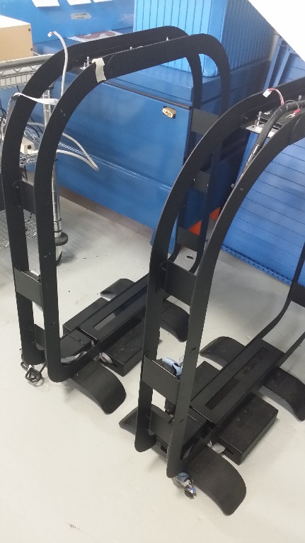
Connect the MPlab ICD-3 Programming Puck (USB) (RX Only) to a PC.

Run Quantronix software titled “IR Gate Config.exe” and select the tabs for Rx.

If necessary, select the appropriate Rx programming files from the Quantronix Tx/Rx Firmware folder.

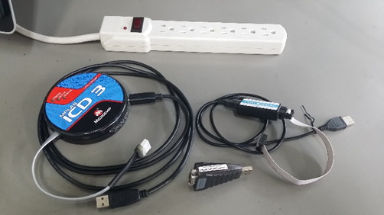

(Test)

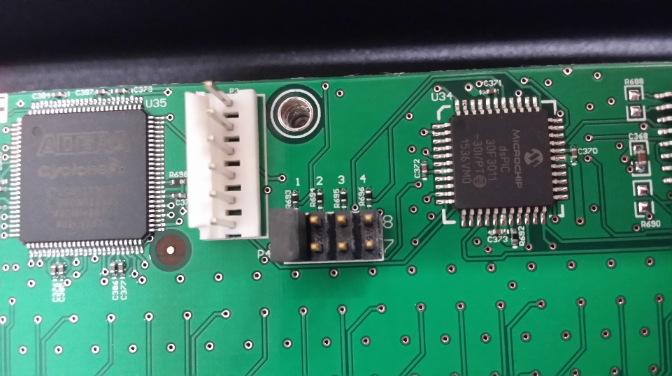
Install one jumper at P4 position 1 which is pins 1 & 2.

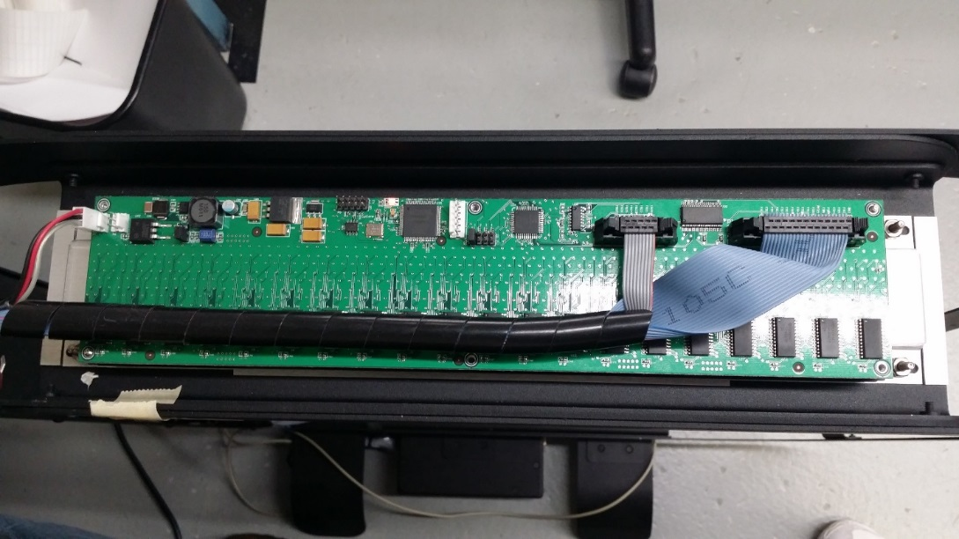
Place the UIT onto the fixture using the two locator pins with the LED’s facing downward.

Connect serial cable/cables to the UIT.

Align and Connect the ICD3 to port P3

Align and Connect the USB Blaster to port P5.

Align and Connect the Power Plug to Port P6 or P7 (Doesn’t matter which one)

Power up the UIT via the power strip. Power LED should light.

Using IR Gate Config; program the:

Hit F3 to kick off Altera Micro-controller (USB Blaster) which takes about 1 second. Watch for confirmation. Press any key then close the window.

Hit F4 to kick off Pic Micro-controller (ICD3) which takes a few seconds. Watch for confirmation.

Press any key, close the “Cycle Power” dialog and Cycle Power.

Select the Test button and wait for the Green progress bar to finish. (About 5 seconds).

Any errors will be reported in the Black GUI area as green reference numbers.
6.13 Apply minimal Loctite 403 glue with fine point nozzle in between LED’s D320 & D316 and D1 & D5. This is to secure D320 and D1, due too small pads easily snapping off during shipping & handling.

FAILED BOARDS:

Failed UUTs are to be retested, and if UUT fails a second time, technician will troubleshoot for failures and rework as applicable.

All reworked UUTs are to be retested.

TROUBLESHOOTING
8.1 Failed LED’s may just need a small nudge to align them closer to silkscreen.

